FTK Imager:
Mount Image File, Recover Deleted File

Course Name: FRS301-Digital Forensics
Student Name: Nguyễn Trần Vinh – SE160258
Instructor Name: Lê Tiến Dũng
Lab Due Date: 7/2/2023

Section 0. Background Information
- What is FTK Imager?
  - The FTK toolkit includes a standalone disk imaging program called FTK Imager. The FTK Imager has the ability to save an image of a hard disk in one file or in segments that may be later reconstructed.
  - It calculates MD5 hash values and confirms the integrity of the data before closing the files.
  - In addition to the FTK Imager tool can mount devices (e.g., drives) and recover deleted files.
- Pre-Requisite
  - Install FTK Imager
  - Create Virtual Hard Drive, Delete File, Recover File
    - Note: This lab is necessary, because you will need to create a Virtual Hard Drive.
  - Create Disk Image after Deleting a Picture
    - Note: This lab is necessary, because you will need to create an image after deleting a file.
- Lab Notes
  - In this lab we will do the following:
    - Mount the Image File.
    - View the deleted file.
    - Recover the deleted file.
    - Compare the MD5 sum of the image after work has been completed to its' original MD5 sum.

Section 1: Log into WXP-SP2
- Start VMware Player
  - Instructions
    - For Windows 7
      - Click Start Button
      - Search for "vmware player"
      - Click VMware Player
    - For Windows XP
      - Starts --> Programs --> VMware Player

- Start Up WXP-SP2.
  - Instructions:
    - Click on WXP-SP2
    - Click on Edit virtual machine Settings
  - Note(FYI):
    - For those of you not part of my class, this is a Windows XP machine running SP2.
- Edit Virtual Machine Settings
  - Instructions:
    - Click on Network Adapter
    - Click on the Bridged Radio button
    - Click on the OK Button

- Play Virtual Machine
  - Instructions:
    - Click on WXP-SP2
    - Click on Play virtual machine

- Logging into WXP-SP2.
  - Instructions:
    - Click on Administrator
    - Password: Supply Password
    - Press <Enter> or Click the Arrow

- Open a Command Prompt
  - Instructions:
    - Start --> All Programs --> Accessories --> Command Prompt

- Obtain WXP-SP2's IP Address
  - Instructions:
    - ipconfig
  - Note(FYI):
    - In my case, WXP-SP2's IP Address 192.168.172.42.
    - This is the IP Address of the Victim Machine that will be attacked by Metasploit.
    - Record your WXP-SP2's IP Address..
Section 2: Start FTK Imager
- Start FTK Imager
  - Instructions:
    - Click on the Start Button
    - All Programs --> AccessData --> FTK Imager --> FTK Imager

Section 3: Mount Image
- Add Evidence
  - Instructions:
    - File --> Add Evidence Item...
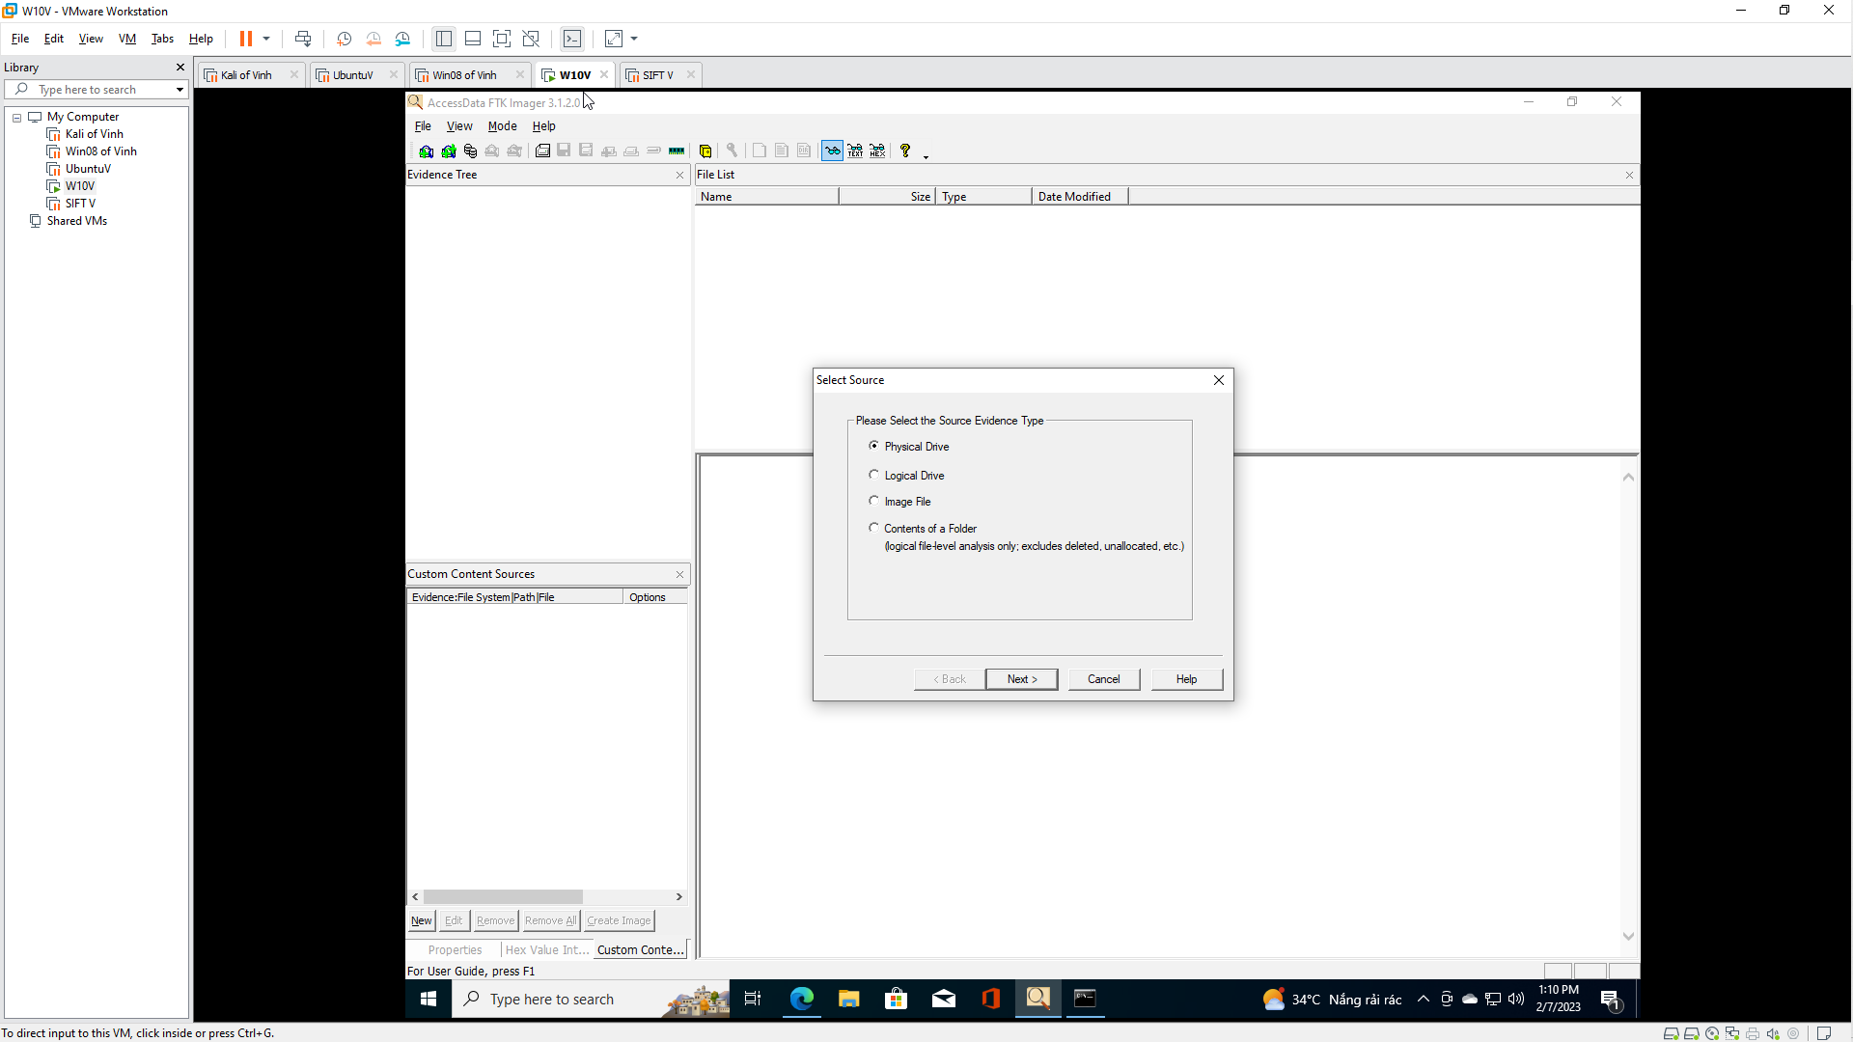

- Select Source
  - Instructions:
    - Click on the Image File radio button
    - Click the Next Button
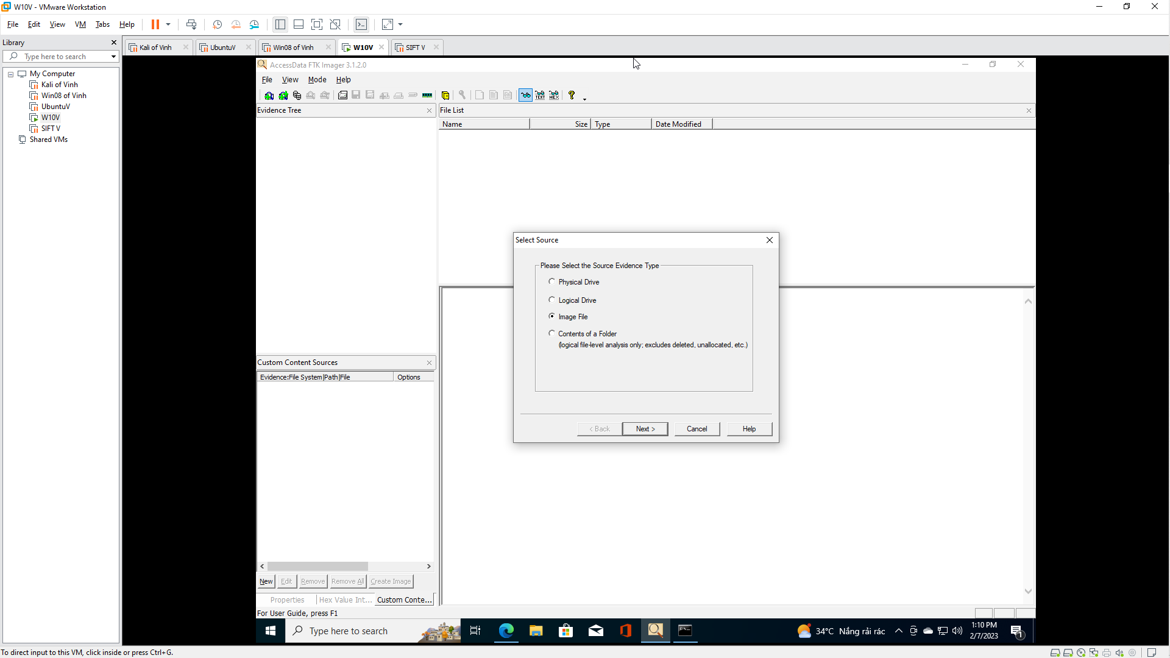

- Select File
  - Instructions:
    - Click the Browse Button
    - Navigate to C:\FORENSICS
    - Select practice-01.001
    - Click the Open Button
    - Click the Finish Button
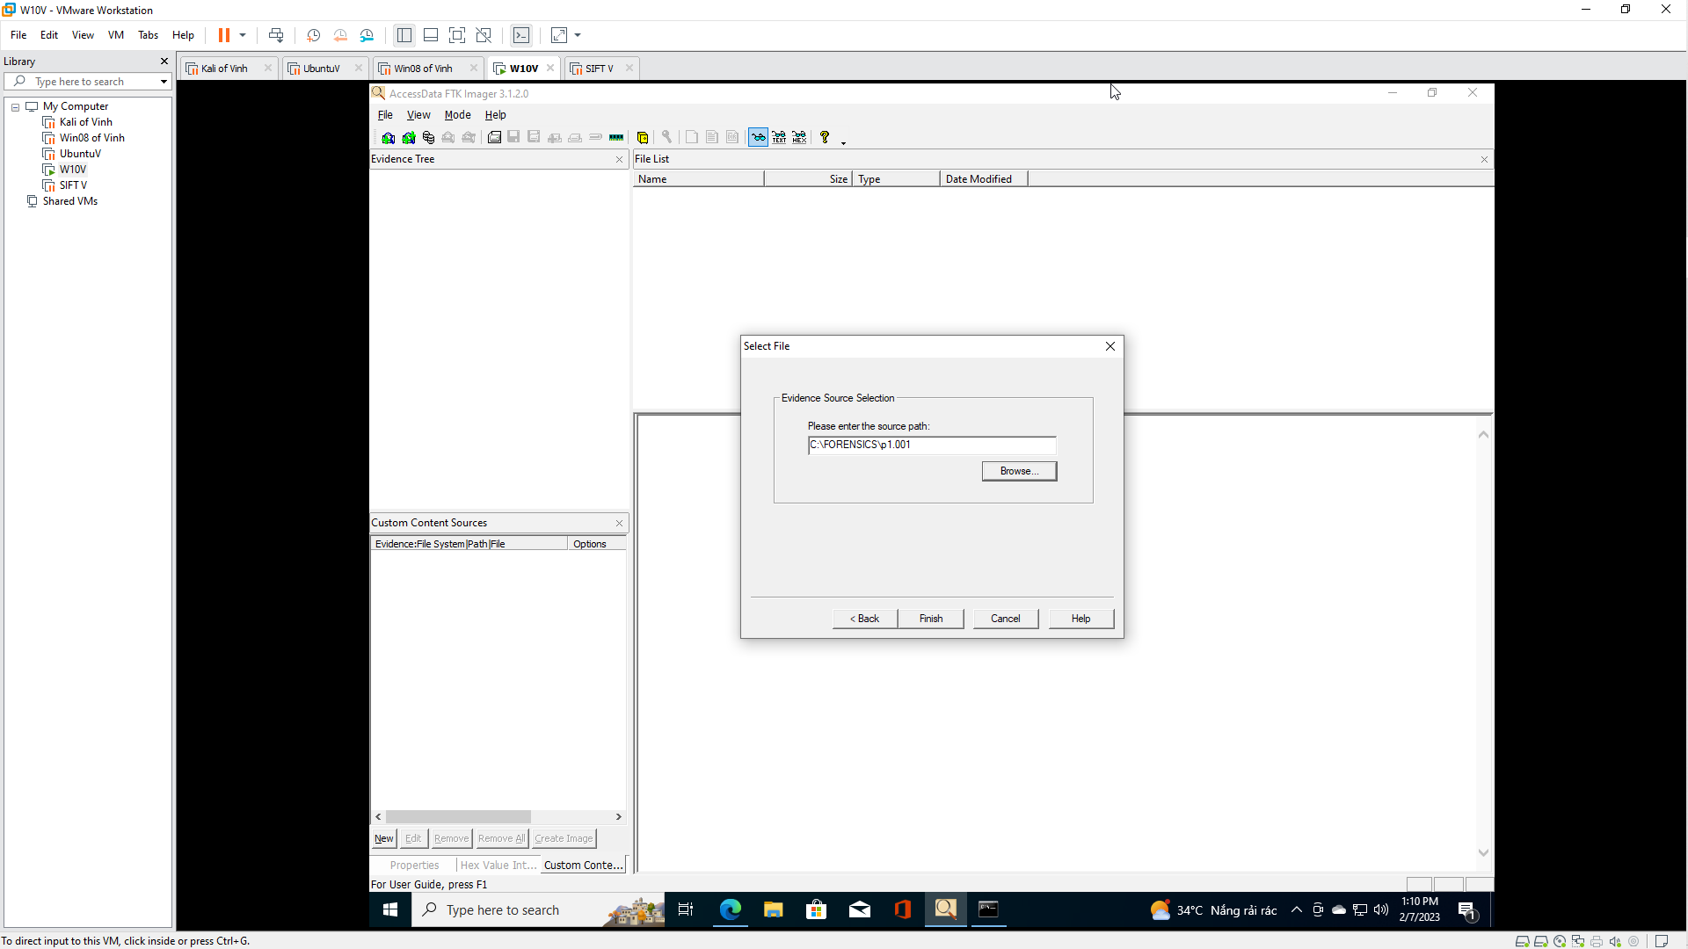

Section 4: View Deleted Image
- View Deleted File(s) in the Recycler
  - Instructions:
    - Navigate to practice-01-001 --> Partition 1 --> FTK[NTFS] --> [root] --> RECYCLER --> RECYCLER SUBDIR
      - The RECYCLER SUBDIR Directory name varies
    - Click on the jpg file if it exists.
      - The naming convention of existing jpg's also varies.
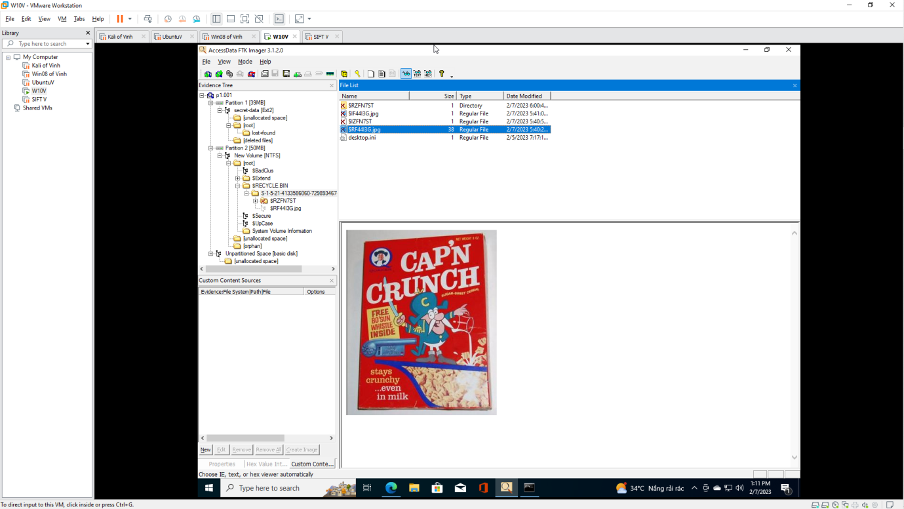

- View Deleted File(s) in [unallocated space]
  - Instructions:
    - Navigate to practice-01-001 --> Partition 1 --> FTK [NTFS] --> [root] --> [unallocated space]
    - Scroll through all the files until you see the Captain Crunch Picture
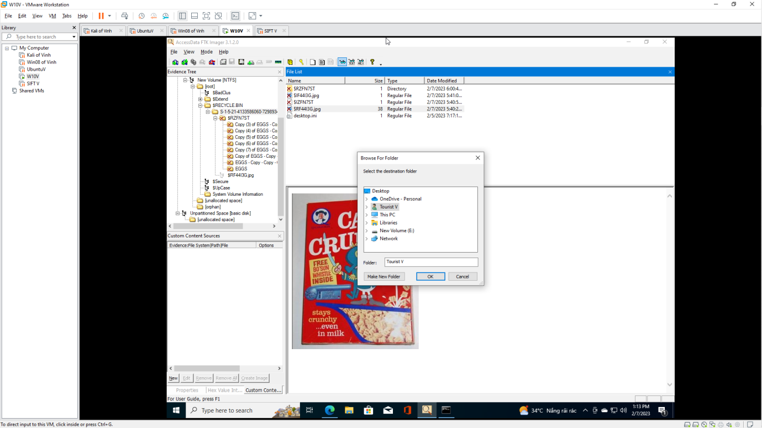

Section 5: Recover Deleted Image
- Export File
  - Instructions:
    - Right Click on the file that contains the picture
    - Select Export Files...


- Select the destination folder
  - Instructions:
    - Navigate to C:\FORENSICS
    - Click the OK Button
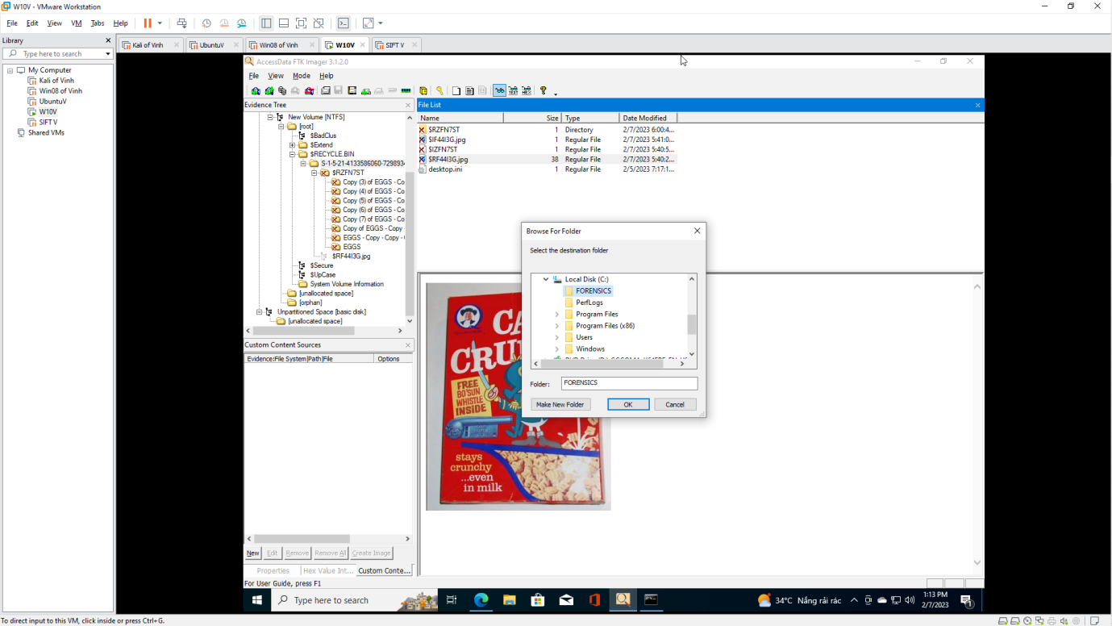

- Export Results
  - Instructions:
    - Click the OK Button
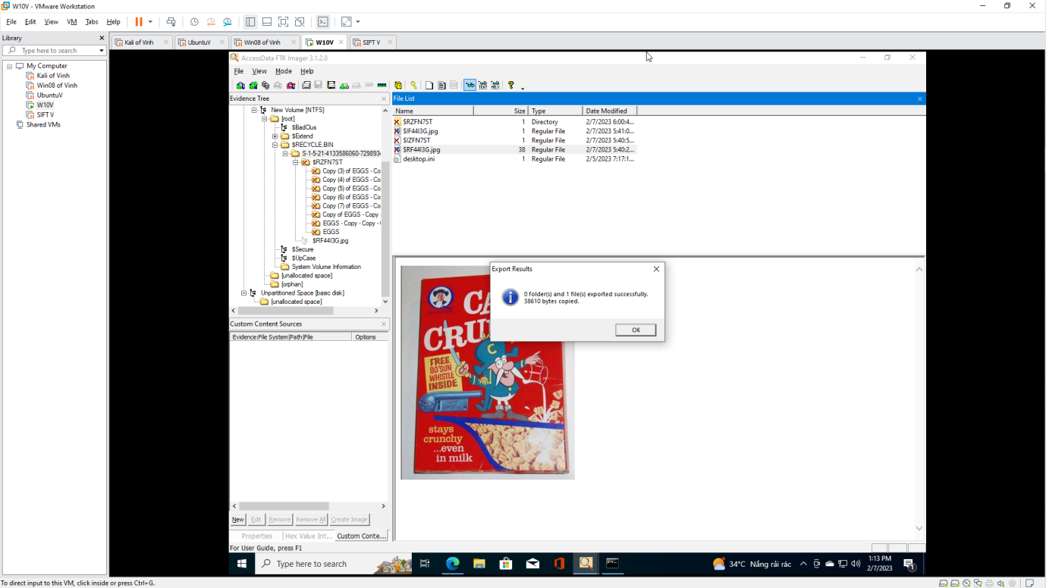

Section 6: View Recoverd Picture
- Open My Computer
  - Instructions:
    - Click the Start Button
    - Click on My Computer
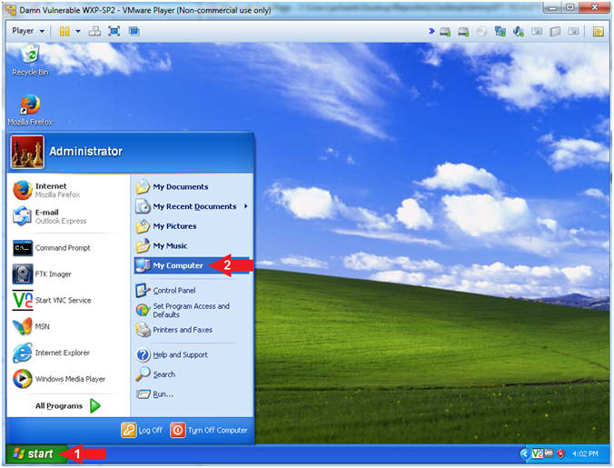
- Rename File
  - Instructions:
    - Navigate to C:\FORENSICS
    - Right Click on the filename that contain all numbers
      - In my case the filename is 103415. In your case, it will probably be named differently.
    - Click Rename
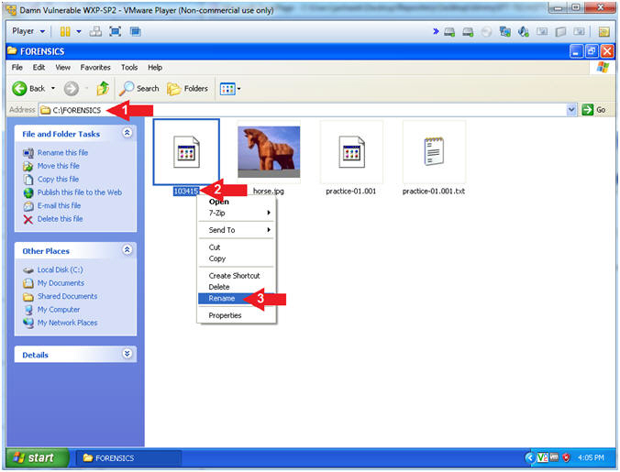

- Name File
  - Instructions:
    - Rename file to "captain.jpg"
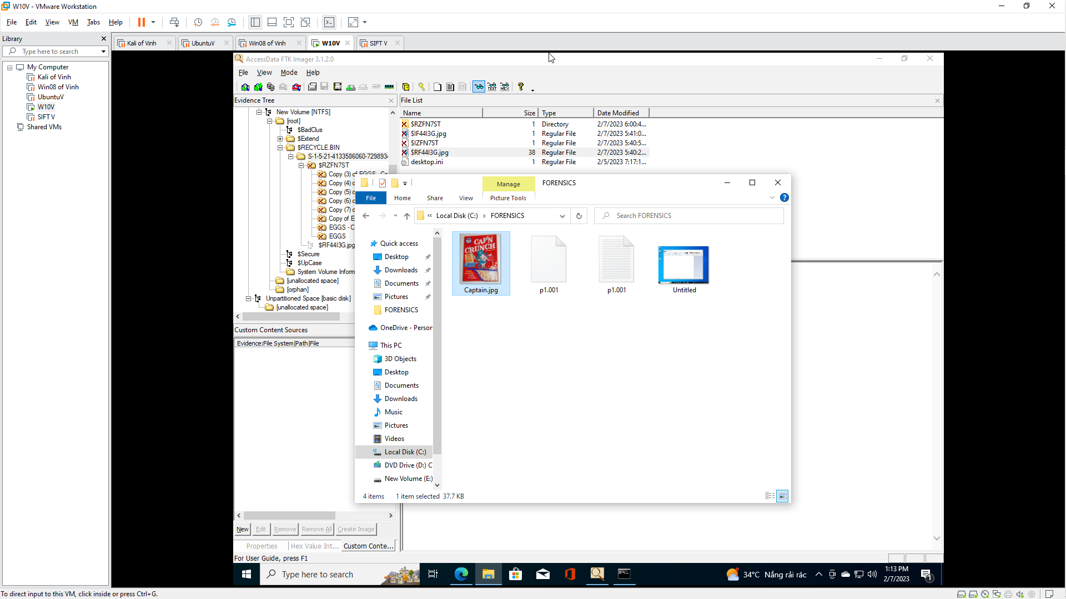
- Open File
  - Instructions:
    - Right Click "captain.jpg"
    - Open With --> Windows Picture and Fax Viewer

- View File
  - Note(FYI):
    - CAP'N Crunch was a h4x0r.... nice whistle.
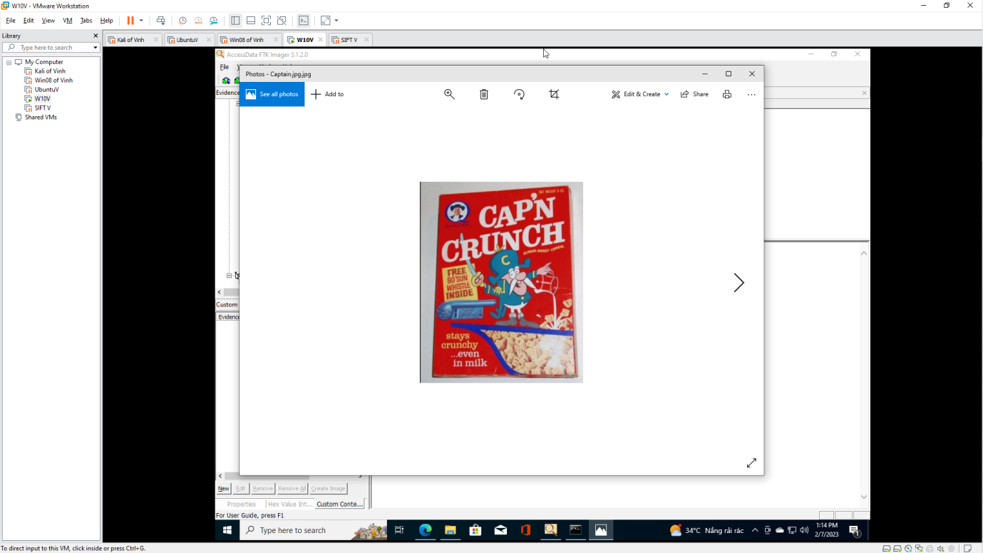

Section 7: Calculate Post MD5 Hash
- Verify Image
  - Instructions:
    - Right Click practice-01-001
    - Click on Verify Drive/Image
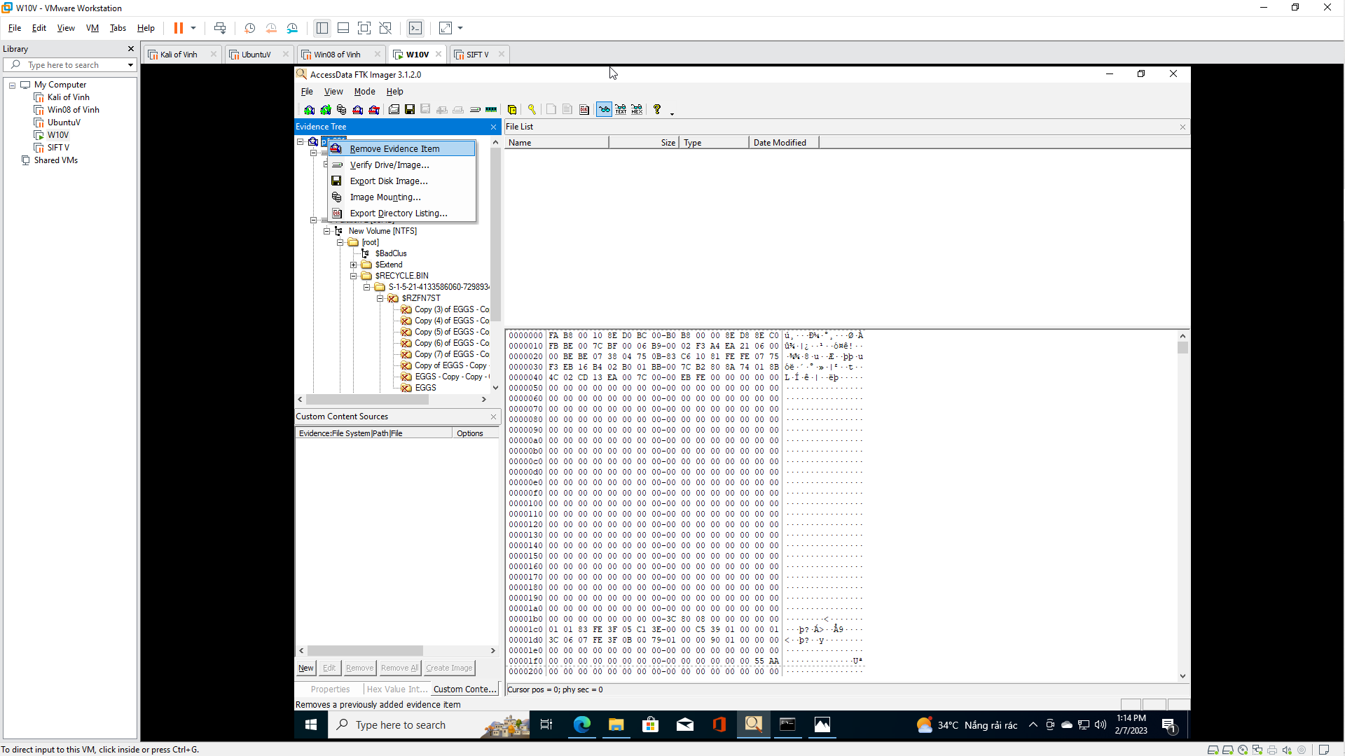

- Drive/Image Verify Results
  - Instructions:
    - Copy the last 4 characters of your MD5 Hash
      - In my case, it is 6e9c.
    - Do Not Click the Close Button
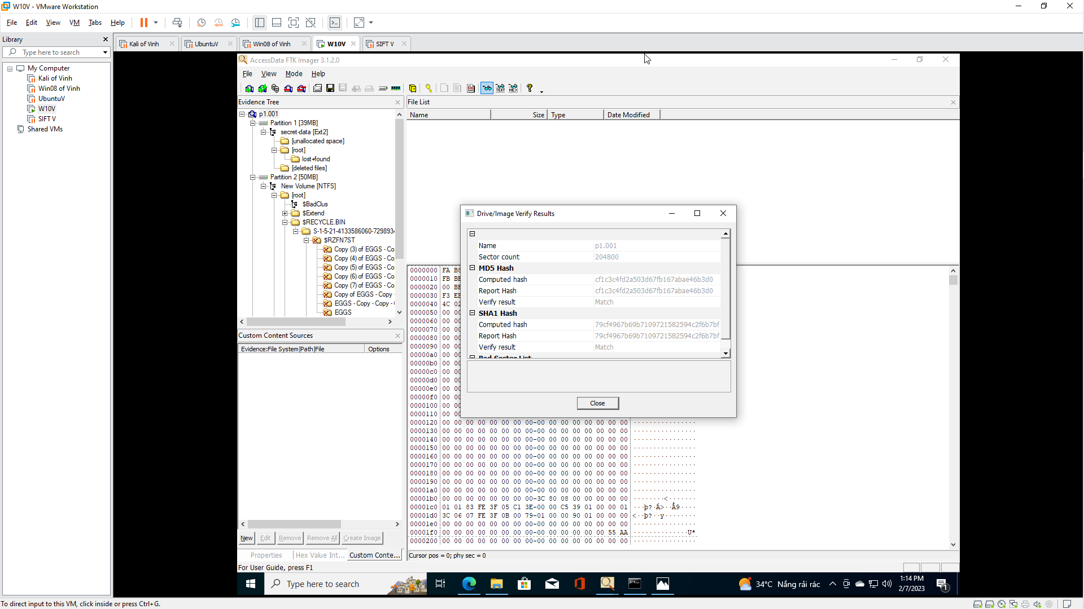
Section 8: Proof of Lab
- Open a Command Prompt
  - Instructions:
    - Start --> All Programs --> Accessories --> Command Prompt

- Proof of Lab
  - Instructions:
    - cd C:\FORENSICS
    - type practice-01.001.txt | findstr "cf1c"
      - Replace "cf1c" with the string you obtained from (Section 7, Step 2)
      - This step verifies that MD5 Hash did not change since the image was first created.
    - date /t
    - echo "Your Name"
      - This should be your actual name.
      - e.g., echo "John Gray"
  - Proof of Lab Instructions
    - Press both the <Ctrl> and <Alt> keys at the same time.
    - Do a <PrtScn>
    - Paste into a word document
    - Upload to Moodle
